Free MTBF Calculator Installation

ALD MTBF Calculator is a free software tool for Reliability Prediction, supporting more than 20 reliability prediction standards. MTBF Calculator is a Windows Desktop application, you should download it from our web site and install on your PC.

Prerequisites  
PC with Windows 2000/XP/Vista  
Administrator user permissions  
50 MB free disk space (tool contains electronic component library with 40000 elements)  
256 MB RAM  
  
Installation Guide

To install and start using MTBF calculator, please follow the instructions below:  
1. Click on MTBF Calculator download link: [Download Free MTBF Calculator](http://www.isditalia.it/?page_id=1517) or go to [ISD ITALIA Software Downloads](http://www.isditalia.it/?page_id=93) page.  
2. Fill in your contact information.  
3. Direct link to installation package will appear - click on it.  
4. Save the downloaded file to your computer and start it, or open it directly after downloading.  
5. Installation wizard will guide you through the installation steps.  
6. Run the installed software from A.L.D. Engineering group in the Start menu - MTBF Calculator screen will appear:  
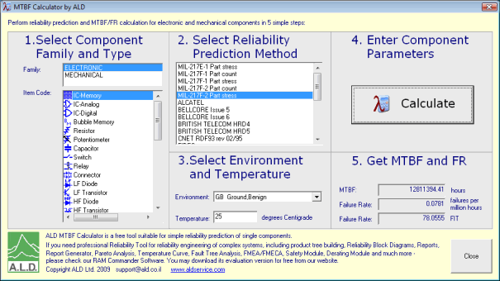  
7. It is possible that you will see the following screen after running MTBF Calculator:  
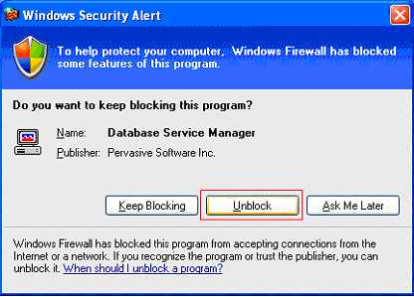  
8. Press "Unblock" for the Pervasive Database Service Manager - it is verified database driver from Pervasive Software which will not harm your computer and it is required for MTBF Calculator operation.  
  
See [Free MTBF Calculator User Guide](http://www.isditalia.it/Free_MTBF_Calculator_user_Guide.docx)for usage instructions.  
  
To uninstall the ALD MTBF Calculator, open Control Panel, select "Add/Remove Windows Programs", select MTBF calculator in the list and press Remove. The software will be completely removed.